Emalahleni Council Portal v2 — Development Summary

**Date:** October 19, 2026
— SaaS Digital Asset Management Platform
**Developer:** Sipho Nzilwane with Ai assistance GitHub Copilot (Poolside: Laguna S 2.1)
**Status:** MVP Complete — Ready for Production Hardening

1. Executive Summary

Built a full-stack Digital Asset Management (DAM) platform from scratch, migrating from a legacy Phoca Download Joomla component to a modern cloud-native/local architecture. The system provides a complete document repository for councillors and top management with ACL-based access control, file preview/playback, social features (comments/ratings), and a statistics dashboard.

Architecture Overview

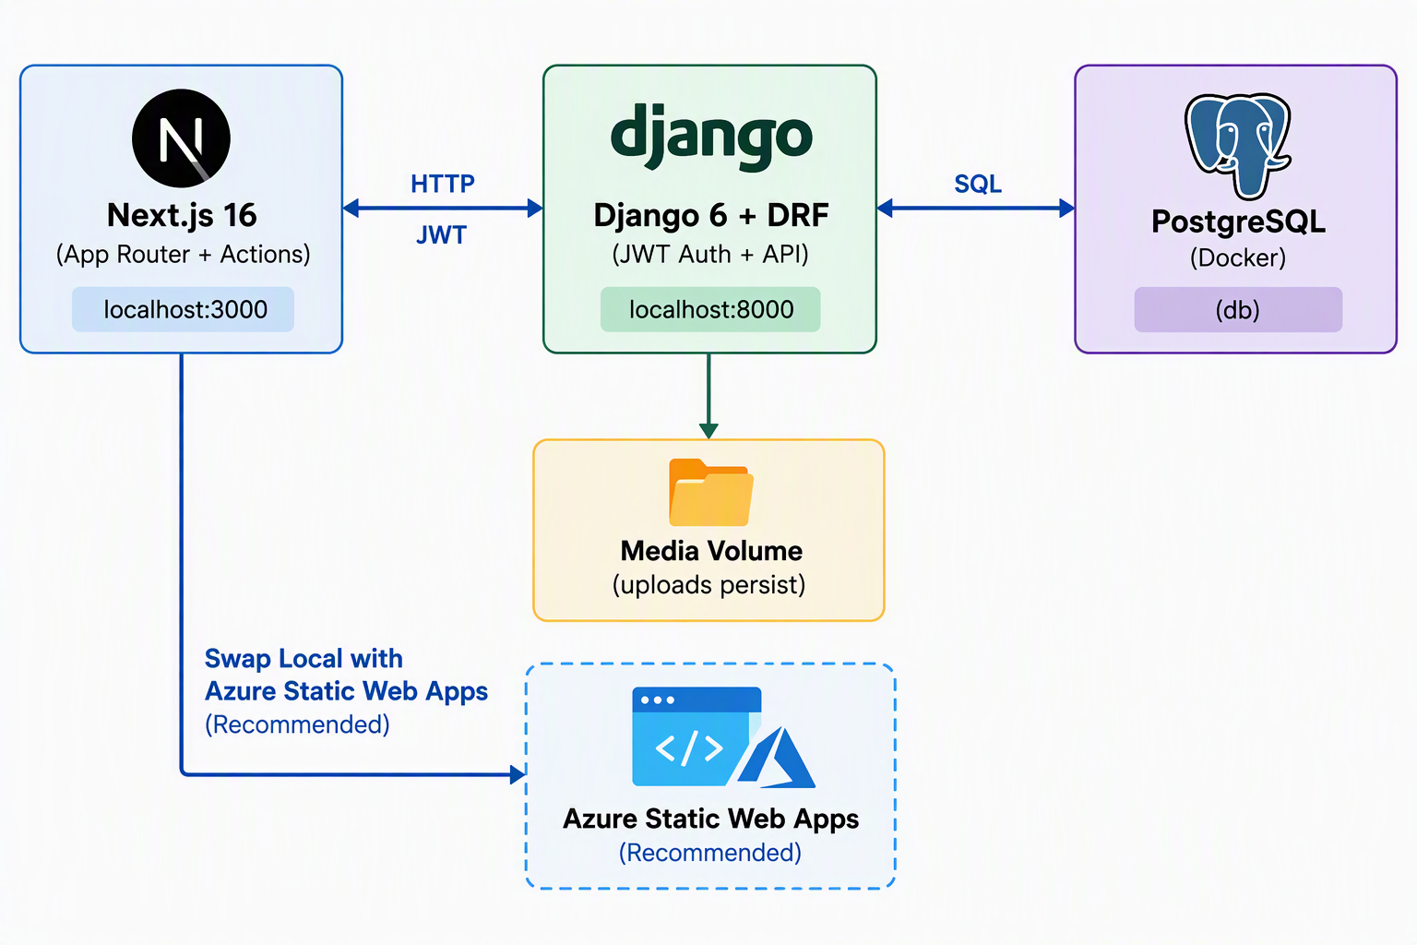

Tech Stack

Layer | Technology
**Frontend** | Next.js 16 (Turbopack), React 19, TypeScript, Tailwind CSS v4, shadcn/ui, lucide-react, Radix UI
**Backend** | Django 6.1, Django REST Framework, djangorestframework-simplejwt, django-filter, django-cors-headers, python-magic
**Database** | PostgreSQL 15 (Docker), SQLite fallback (dev)
**Auth** | JWT tokens (Simple JWT) with session auth fallback
**Infrastructure** | Docker Compose (web, db, adminer, frontend), named volumes
Endpoint | Method
`/api/auth/token/` | POST
`/api/auth/token/refresh/` | POST
`/api/auth/me/` | GET
`/api/auth/login/logout/` | POST
`/api/auth/csrf/` | GET
`/api/categories/` | GET
`/api/categories/<slug>/` | GET
`/api/categories/<slug>/files/` | GET
`/api/files/` | GET
`/api/files/<id>/` | GET
`/api/files/<id>/download/` | GET
`/api/files/upload/` | POST
`/api/files/<id>/replace/` | POST
`/api/files/content-types/` | GET
`/api/comments/` | GET/POST
`/api/ratings/` | GET/POST
`/api/admin/stats/summary/` | GET
`/api/admin/stats/downloads/` | GET
File | Purpose
`lib/api.ts` | Full API client with JWT auth, CSRF handling, pagination unwrapping, typed interfaces
`lib/file-types.ts` | Extension → preview-kind mapping (pdf/image/audio/video/download)
`components/auth-provider.tsx` | React context for JWT auth (login/logout/reload/auto-refresh)
`components/category-tree.tsx` | Recursive collapsible category browser
`components/file-card.tsx` | Card view with title, type, size, rating, download button
`components/preview.tsx` | Polymorphic preview (PDF iframe, img, audio, video, download link)
`components/star-rating.tsx` | Interactive 1–5 star widget with hover + optimistic updates
`components/comment-list.tsx` | Comment display with user avatar + timestamp
`components/comment-form.tsx` | Comment submission with CSRF + error handling
`app/page.tsx` | Landing page with logo + Sign In button + redirect-if-authenticated
`app/login/page.tsx` | JWT login form
`app/layout.tsx` | Root layout with AuthProvider + header
File | Purpose
`app/dashboard/layout.tsx` | Dashboard layout (sidebar + header + auth guard)
`app/dashboard/page.tsx` | Dashboard home with stats cards + collections
`app/dashboard/assets/page.tsx` | Asset management (grid/table toggle, sort, filter)
`app/dashboard/assets/[id]/page.tsx` | Asset detail (preview, rating, comments, download)
`app/dashboard/collections/page.tsx` | Collection browser with search
`app/dashboard/collections/[slug]/page.tsx` | Collection detail view
`components/app-sidebar.tsx` | Collapsible sidebar with shadcn Tooltip + logo
`components/app-header.tsx` | Top bar with search + user dropdown
Service | URL
**Next.js Frontend** | http://localhost:3000
**Django Backend** | http://127.0.0.1:8000
**Django Admin** | http://127.0.0.1:8000/admin/
**JWT Token** | POST http://127.0.0.1:8000/api/auth/token/
|---|---|

2. What Was Built

Phase 1-2: Backend Foundation (Python/Django)

**6 models created** in `documents/models.py`:

- **Category** — Recursive self-referencing tree for collections
- ACL via `access_groups`/`access_users` M2M fields
- `owner`, `is_published`, `ordering` fields
- Image field for category icons

- **StoredFile** — Asset with dual storage support
- `StorageKind.LOCAL` or `StorageKind.EXTERNAL` (URL)
- MIME type detection via `python-magic`
- `filesize`, `download_count`, `is_published` fields
- DB constraint: must have payload for its storage type

- **Comment** — Generic FK (works for both files AND categories)
- `is_approved` flag for moderation
- User attribution + timestamp

- **Rating** — 1–5 stars, one per user per object
- `unique_together` constraint prevents duplicates
- Upsert behavior via `update_or_create`

- **DownloadLog** — Tracks every download (user, IP, timestamp)

- **UploadLog** — Tracks every upload/replace (action: created/replaced)

**16 API endpoints** — All verified working with JWT auth:

|---|---|---|

Phase 3: Social Layer + ACL Refinement

- **Comment ACL**: `CommentViewSet.perform_create()` validates target object exists + user can view
- **Rating upsert**: `RatingSerializer` uses `update_or_create` — verified count stays at 1 after updating
- **ACL `get_queryset`/`get_object`**: Fixed list/404 issues by returning real QuerySets and applying ACL in `get_object()`
- **`UploadLog.user`** changed to nullable (`null=True, on_delete=SET_NULL`) for system-seeded logs

Phase 4: Frontend Shell (Next.js)

**12 files created** across `app/` and `components/`:

|---|---|

Phase 5: Dashboard UI

**8 new files** for the dashboard experience:

|---|---|

**6 shadcn/ui components** manually created:
- `ui/button.tsx`, `ui/card.tsx`, `ui/input.tsx`
- `ui/avatar.tsx`, `ui/dropdown-menu.tsx`, `ui/tooltip.tsx`, `ui/separator.tsx`, `ui/badge.tsx`

Phase 6: Hardening + Seed Data

- **`seed_portal` management command** — Creates 3 roles (Councillors, TopManagement, Admin — no Public group), 4 root categories + 1 ACL-restricted subcategory, 2 sample files (local text + external URL), and a dev superuser (admin/admin123)
- **JWT authentication** added alongside session auth — `djangorestframework-simplejwt[crypto]`
- **Frontend API client** updated to use JWT Bearer tokens with auto-refresh
- **Pagination handling** — `apiFetch()` automatically unwraps DRF's `{count, next, previous, results}` format
- **Docker Compose** — Added `media` named volume for persistent uploads

Logo Integration

- `emalahleni-logo.png` placed in `public/` folder
- Used as **favicon** (via Next.js metadata `icons`)
- Displayed in **landing page header**, **dashboard sidebar**, and **root layout header**
- Sidebar logo visible in both collapsed and expanded states

3. Infrastructure & Development Servers

Both servers are currently running:

|---|---|---|

4. Key Design Decisions

- **JWT over Session Auth** — Better for multi-tenant SaaS, mobile clients, and API-first design
- **ACL at model level** — Single `can_view()`/`can_download()` helper used by all endpoints
- **Generic FKs for comments/ratings** — Same Comment/Rating model works for files AND categories
- **ContentType API endpoint** — Frontend resolves IDs dynamically instead of hardcoding
- **Dynamic routes** (`export const dynamic = 'force-dynamic'`) — Required for `useParams()` in Next.js 16 with App Router
- **No Public group** — Authenticated users see unrestricted published content; no anonymous access

5. Next Steps (Recommended)

Priority 1: Multi-Tenancy (Accounts App)
Create an `accounts` app with User profiles, Teams/Workspaces, and Membership models. Filter all queries by team to isolate assets per organization.

Priority 2: Client Sharing
Add a `SharedLink` model with:
- Time-limited URLs (expiry datetime)
- Optional password protection
- Download tracking per shared link
- Public access endpoint (`/share/<token>/`)

Priority 3: Production Docker Deployment
- cd python/
docker compose up -d --build
- Switch from SQLite to PostgreSQL
- Add S3 storage backend (`django-storages`)
- Set `DEBUG=0`, configure `ALLOWED_HOSTS`
- Add nginx for media serving with `X-Accel-Redirect`

Priority 4: Advanced Features
- Activity feed (audit trail of all actions)
- Bulk upload + ZIP extraction
- File versioning (history of replaced files)
- Search (full-text search via PostgreSQL `tsvector`)
- Real-time notifications (WebSocket or polling)

Priority 5: Testing & CI
- Unit tests for models + API endpoints
- Integration tests for the full upload→download→comment→rate flow
- CI/CD pipeline (GitHub Actions)
- Docker health checks

6. How to Run

Development:
- # Terminal 1: Django backend
cd python/
.venv/bin/python manage.py runserver 8000
# Terminal 2: Next.js frontend
cd frontend/
pnpm dev
# Seed data (if needed)
cd python/
.venv/bin/python manage.py seed_portal --superuser --clear

Production (Docker):
- cd python/
docker compose up -d --build

7. API Documentation

Authentication (JWT)
- # Login
curl -X POST http://127.0.0.1:8000/api/auth/token/ \
-H "Content-Type: application/json" \
-d '{"username":"admin","password":"admin123"}'
# Response: {"refresh": "...", "access": "..."}
# Use token
curl http://127.0.0.1:8000/api/categories/ \
-H "Authorization: Bearer <access_token>"

Upload (multipart)
- curl -X POST http://127.0.0.1:8000/api/files/upload/ \
-H "Authorization: Bearer <token>" \
-F "file=@document.pdf" \
-F "title=Annual Report" \
-F "slug=annual-report-2026" \
-F "category=policies" \
-F "description=2026 financial report"
Quick recap of what's ready:

## 📦 Deliverables
**Running Services:**
- Frontend: http://localhost:3000
- Backend: http://127.0.0.1:8000
- Admin: http://127.0.0.1:8000/admin/ (admin/admin123)

| Route | Purpose |
|---|---|
| `http://localhost:3000` | Landing page with logo + Sign In |
| `http://localhost:3000/login` | JWT login form |
| `http://localhost:3000/dashboard` | Dashboard with stats cards |
| `http://localhost:3000/dashboard/assets` | Asset grid/table view |
| `http://localhost:3000/dashboard/collections` | Category browser |

*Prepared by Sipho Nzilwane on 2026-10-19*

